**T62 Tutorial 1**

Question 1

Determine the decimal value of the bit pattern 1000 0110, if it is a

1. 8-bit unsigned binary number

**134**

(b) 8-bit 2’s complement number

**-122**

(c) BCD code

**86**

(3 marks)

Question 2

Given the decimal number 20x4 (2004). x is the last digit of your student ID number. Represent it as

1. unsigned binary number

**11111010100**

1. hexadecimal number

**7D4**

(4 marks)

Question 3

Given two decimal numbers A = 207 and B = 59, convert A (11001111) and B (111011) into unsigned binary numbers.

1. perform A + B

**100001010**

1. perform A – B

**10010100**

1. perform A ÷ B

**11, Remainder: 11110**

(3 marks)

Question 4

Given two decimal numbers A = 159 and B = -27, convert A (010011111) and B (111100101) into 2’s complement numbers.

1. perform A + B

**010000100**

1. perform A – B

**010111010**

(4 marks)

Question 5

Given two hexadecimal numbers A = BCD and B = B6.

1. perform A + B

**C83**

1. perform A – B

**B17**

(2 marks)

Question 6

Given two decimal numbers A = 238 and B = 59, convert A (001000111000) and B (01011001) into BCD codes. Perform A + B.

**001010010111**

(2 marks)

Question 7

Given a 32-bit address bus.

1. find the total amount of memory in MB

**4096MB**

1. find the total amount of memory in GB

**4GB**

(2 marks)

Question 8

In a given byte-addressable computer with an 18-bit address bus, memory locations 10000h to 1FFFFh are available for user programs. Each RAM chip is 64 KB. Design an address decoder circuit, assuming active low memory chip select signal.

2 to 4 active low decoder

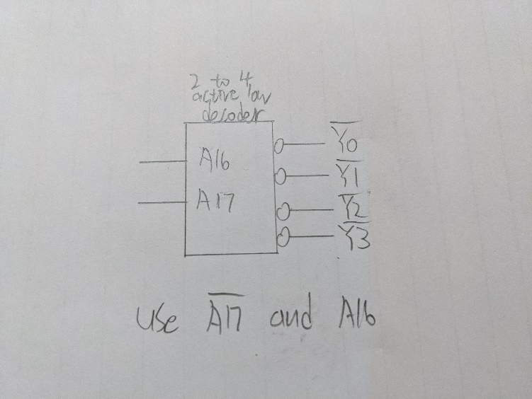

Use $\overline{A17}$ and A16

(4 marks)

**Submission**

Enter your name, student ID number, and the answers in the MS Word document file. Re-name the file with your student ID number, e.g. 12345678.docx. **Deduct 4 marks for wrong file name.**

Submit the file by e-mail ([itklchan@cityu.edu.hk](mailto:itklchan@cityu.edu.hk)) before 3:00 pm. **Late submission will not be accepted.**